Caroline Cliona Boyle

Data Journalism

February 12, 2022

**Word Cloud Practice**

Mark Zuckerberg Senate Hearing Transcript

<https://www.washingtonpost.com/news/the-switch/wp/2018/04/10/transcript-of-mark-zuckerbergs-senate-hearing/>

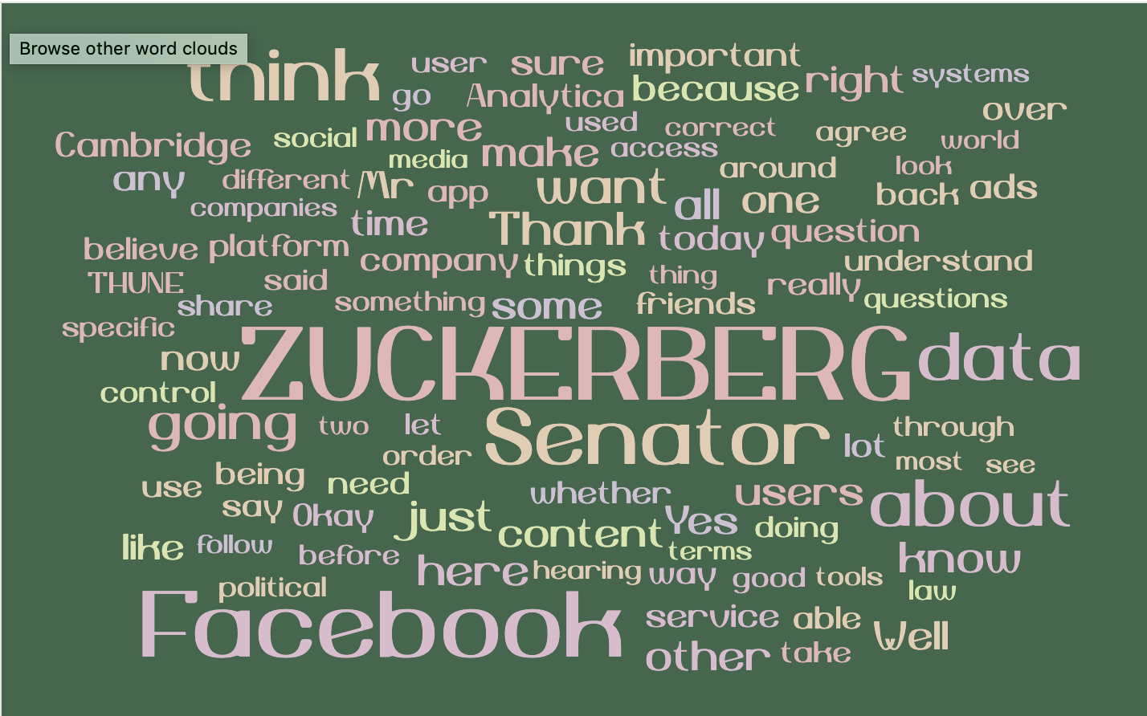

In 2018, Mark Zuckerberg became embroiled in a national scandal that resulted in a Senate Hearing on the data privacy standards. Conglomerate Facebook, now called Meta, unconsensually harvested data from its Facebook users and sold it to British data firm Cambridge Analytica. The implications of this decision were widespread — not only did the question of global user data protection arise, but also brought to light the impropriety of tech companies appropriating data for adverts that were used to obstruct election outcomes. In this word cloud, the transcript of the Zuckerberg hearing translates into five central words showing through the most: Zuckerberg, Facebook, think, Senator and data. In recent light of further payouts Facebook has made related to obstructing user data privacy, this hearing foreshadows the damage that big tech has inflicted on consumers who unknowingly had their data compromised.